[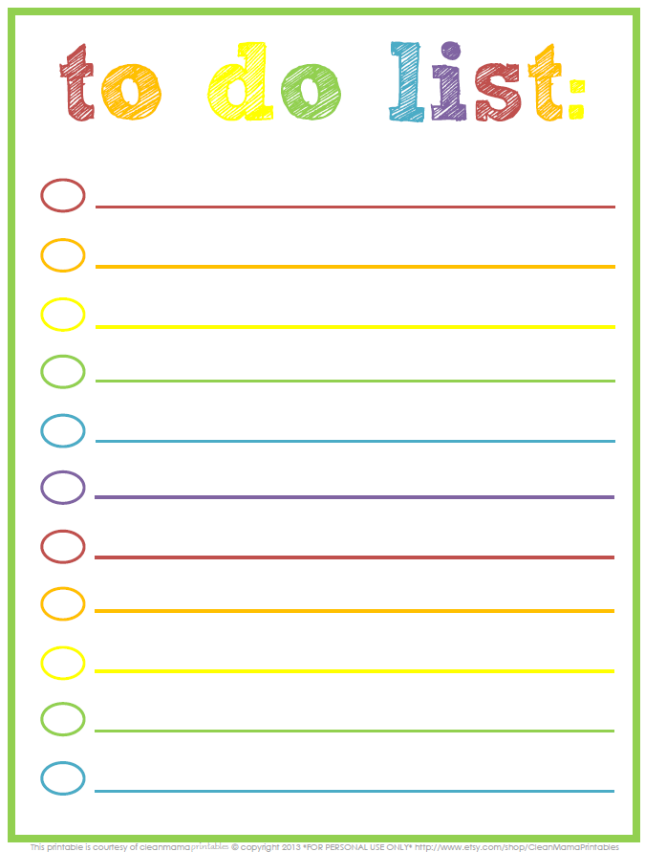](http://www.google.nl/url?sa=i&rct=j&q=&esrc=s&source=images&cd=&cad=rja&uact=8&ved=0ahUKEwj_9tfDkvvYAhVH7VMKHQhqB0AQjRwIBw&url=http://www.nederlandstaligesoftware.nl/apps/to-do-list/&psig=AOvVaw1BwQNeSjCvwNCxsOtZouX3&ust=1517245596782276)